Essential Readings

Week 1: Startup Fundamentals

- Reading: Introduction to startups
- Reading: Markets Research (ideation)
- Watching: How to start a startup by Sam Altman
Bonus: Joel Spolsky at Startup School 2012

Week 2: SAAS and Lean Fundamentals

1. How do typical SaaS companies operate?
2. What are the different types of SaaS companies?
3. What are the common business models adopted by SaaS companies?
4. How do SaaS companies acquire users, and what are the typical customer acquisition costs (CAC)?
5. What sales and marketing strategies do SaaS companies use to drive growth?
6. What is the lean execution model, and what are its limitations?

Recommended Readings:
- How to start a SAAS business
- SAAS Business Model
- How to Build a SAAS with $0
- The Lean Startup Methodology
- Why the Lean Startup Changes Everything
- 6 things wrong with the 'Lean Startup' model (and what to do about it)
- Lean Start-Up, and How It Almost Killed Our Company

Week 3: Fundamental of Neural netwworks

Recommended Readings:
1. Chapter 1. Introduction to Building AI Applications with Foundation Models
2. 3Blue1Brown: https://youtu.be/aircAruvnKk
3. The original Nature publication: https://www.nature.com/articles/nature14539

Week 4: Readings relevant to Ideation Phase

Recommended Readings:
- Disciplined Entrepreneurship: 24 steps to a successful startup
- How to do market research for a startup
- How to Determine If There's a Market for Your Business Idea

Unsorted

Watching:
- https://youtu.be/v9JBMnxuPX8
- Vertical AI Agents Could Be 10X Bigger Than SaaS
- https://www.youtube.com/watch?v=eBVi_sLaYsc
- https://youtu.be/xlQB_0Nzoog
- Annual letter by chamath - social capital
Learn about the fundamental process
- https://medium.com/swlh/what-i-learned-from-my-first-month-at-y-combinator-5b35fb9ebb7b

Reading: https://www.ycombinator.com/library/4D-yc-s-essential-startup-advice
Watching: V
  - https://www.cortes.design/post/best-saas-landing-page-examples-inspiration

- https://www.openvc.app/blog/startup-financial-model
- https://www.entrepreneur.com/bookstore

https://platformsandnetworks.blogspot.com/2011/01/launching-tech-ventures-part-iv.html

https://www.cs.princeton.edu/courses/archive/spring25/cos448/schedule.html
https://youtu.be/2Nd33eVmDhM

https://youtu.be/v0gjI__RyCY

Appendix - A - book list
Given your goal to build a sustainable, profitable, and pragmatic startup (rather than a high-growth, VC-driven unicorn), I’ll categorize and prioritize these books based on their relevance:

Highly Recommended (Immediately Practical for a "Normal" Startup):
- Rework – Jason Fried & David Heinemeier Hansson
  - Perfect for bootstrapped startups, emphasizes profitability, simplicity, and actionable business advice.
- The E-Myth Revisited – Michael Gerber
  - Essential for understanding how to scale a small business from founder-driven to systems-driven.
- Obviously Awesome – April Dunford
  - Excellent guide on positioning products clearly and effectively—highly practical for product-led businesses.
- Building a StoryBrand – Donald Miller
  - Essential for clarifying messaging and effective communication with customers.
- The Almanack of Naval Ravikant – Eric Jorgenson
  - Practical and philosophical insights on wealth creation, decision-making, and effective entrepreneurship.
- $100M Offers – Alex Hormozi
  - Extremely actionable for crafting compelling offers and pricing strategies

Recommended (Strategic Thinking & Process):
- High Output Management – Andy Grove
  - Practical advice on managing productivity, teams, and operations—beneficial as you scale even modestly.
- The Lean Startup – Eric Ries
  - Fundamental startup methodology: iterate fast, validate market fit, and manage uncertainty effectively.
- Zero to One – Peter Thiel
  - Valuable for understanding differentiation and innovation, though more geared toward ambitious startups.
- Disciplined Entrepreneurship – Bill Aulet
  - Structured, step-by-step guide to startup processes, useful if you appreciate structured frameworks.
Useful for Broader Business and Mindset Context (Less Immediately Actionable):
- Principles – Ray Dalio
  - Broad life and business principles; valuable insights but somewhat abstract or broad in initial stages.
- Measure What Matters – John Doerr
  - Highly useful if your startup grows beyond a small scale, introduces goal-setting and management via OKRs.
- Innovator’s Dilemma – Clayton Christensen
  - Crucial theory on disruption and innovation, but more strategic and less operationally practical for smaller startups.
- Thinking in Bets – Annie Duke
  - Good for learning decision-making under uncertainty, relevant but more general in business applicability.
- Founders at Work – Jessica Livingston
  - Inspirational narratives to normalize the startup journey; good for morale and perspective.
- Diary of a CEO – Steven Bartlett
  - Insightful stories and lessons, but geared toward broad business motivation rather than specific execution.
- The CEO Within – Joseph Bower
  - Focuses more on corporate leadership and governance; less relevant in early-stage, smaller startups.
- Personal MBA – Josh Kaufman (appears twice on your list)
  - General overview of business concepts; useful as foundational knowledge, less specific to startups.

Recommended Reading Order (Tailored to Your Goals):
Immediate Priority (Operational & Practical):
- Rework
- The E-Myth Revisited
- Obviously Awesome
- Building a StoryBrand
- $100M Offers
Next Steps (Scaling & Management):
- High Output Management
- The Lean Startup
- Disciplined Entrepreneurship
Broader Perspective & Mindset (Longer-term reading):
- The Almanack of Naval Ravikant
- Zero to One
- Principles
- Measure What Matters
- Thinking in Bets
- Innovator’s Dilemma

Most Recommended to Start Immediately:
- Rework
- The E-Myth Revisited
- Obviously Awesome

- https://tylertringas.com/micro-saas-ebook/
- The Startup Owner’s Manual.
- Principles by Ray Dalio
- Personal MBA
- Diary of CEO
- The CEO within
- Innovators Dilemma
- Lean Startup
- Measure What Matters – John Doerr
- Personal MBA
- Disciplined Entrepreneurship
- High Output Management – Andy Grove
- $100M Offers – Alex Hormozi
- Obviously Awesome – April Dunford
- Building a StoryBrand – Donald Miller
- The E-Myth Revisited – Michael Gerber
- The Almanack of Naval Ravikant – Eric Jorgenson
- Zero to One – Peter Thiel
- Rework – Basecamp guys: Especially good for bootstrapped or solo/duo founders doing product-led growth.
- Thinking in Bets – Annie Duke: Decision-making under uncertainty = startup life.
- Founders at Work – Jessica Livingston: Real startup war stories that will normalize your struggles.
- Rework by Jason Fried

Appendix B - Awesome People

Paul Graham
- Why: Co-founder of Y Combinator, Graham offers clear, actionable advice on creating value, user-centric design, and fundamental startup building principles.
- Key Resources: Paul Graham Essays, especially:
  - "Startup = Growth"
  - "Do Things That Don't Scale"
  - "How to Get Startup Ideas"

2. Jason Fried & David Heinemeier Hansson
- Why: Founders of Basecamp and authors of books that emphasize profitability, simplicity, bootstrapping, remote work, and sanity over hyper-growth.
- Key Resources: Books such as:
  - Rework
  - Remote: Office Not Required
  - It Doesn’t Have to Be Crazy at Work
  - Blog: Signal v. Noise

3. Naval Ravikant
- Why: Co-founder of AngelList, Naval combines profound wisdom on wealth creation, practical startup advice, and philosophical insights into entrepreneurship.
- Key Resources:
  - The Almanack of Naval Ravikant
  - Naval’s Podcast and tweets.

4. Sahil Lavingia
- Why: Founder of Gumroad, he openly discusses the realities of running a profitable small business rather than chasing aggressive growth.
- Key Resources:
  - His book: The Minimalist Entrepreneur
  - Gumroad's blog and his personal blog.

5. Rob Walling
- Why: An influential figure in bootstrap startups, known for practical advice on building sustainable, profitable businesses without traditional VC funding.
- Key Resources:
  - Podcast: Startups for the Rest of Us
  - Book: Start Small, Stay Small

6. Justin Jackson
- Why: Co-founder of Transistor.fm, a bootstrapped podcast hosting platform; strong advocate for calm, steady, profitable growth.
- Key Resources:
  - Build Your SaaS podcast
  - Blog and newsletters at justinjackson.ca

7. Amy Hoy & Alex Hillman
- Why: Known for their philosophy of customer-first, bootstrapped, profitable product-building. They emphasize audience-driven product design.
- Key Resources:
  - Courses: 30x500 Academy
  - Book: Just Fucking Ship (Amy Hoy)
  - The Tiny MBA (Alex Hillman)

8. Patrick McKenzie (patio11)
- Why: Well-known for insightful writing and practical advice on running small, profitable software businesses and startups without VC pressure.
- Key Resources:
  - Kalzumeus blog
  - His writing on Stripe Atlas guides and Hacker News.

9. Steve Blank
- Why: Considered the godfather of the "lean startup" method, emphasizing customer validation, iteration, and focusing on product-market fit rather than immediate scale.
- Key Resources:
  - Book: The Four Steps to the Epiphany
  - Blog: SteveBlank.com

10. Eric Ries
- Why: Founder of the Lean Startup movement, advocating for iterative, customer-focused product development and practical approaches to building startups.
- Key Resources:
  - Book: The Lean Startup
  - The Lean Startup Blog

Jeff dean:
Andre Karpathy
Andrew NG

Appendix C - Case studies:

- https://www.indiehackers.com/products?businessModel=ads&employeeCount=1-9&minRevenue=9038
- https://cloud.google.com/transform/101-real-world-generative-ai-use-cases-from-industry-leaders
- https://platformsandnetworks.blogspot.com/2011/01/launching-tech-ventures-part-ii-class.html
- https://blog.healthchecks.io/2024/07/running-one-man-saas-9-years-in/
- https://medium.com/@nassuf
- https://canny.io/blog/saas-startup-ramen-profitability/
- Real-World Examples of Simple, Profitable SaaS: https://www.indiehackers.com/products?businessModel=subscriptions&maxRevenue=18509

Appendix D: Tools
- https://platformsandnetworks.blogspot.com/2011/01/launching-tech-ventures-part-iii-tools.html
- https://youtu.be/d0j_n3OOM7c

• Idea Browser - ideabrowser.com
• TLDraw - https://www.tldraw.com/
• Wispr Flow - https://wisprflow.ai/
• Manus - https://manus.im/
• Bolt - https://bolt.new/
• The Vibe Marketer - https://www.thevibemarketer.com/
• Kubera - https://www.kubera.com/
• Lindy - https://www.lindy.ai/
• Lovable - https://lovable.dev/
• Windsurf - https://windsurf.com/
• Cursor - https://www.cursor.com/
• Supabase - https://supabase.com/
• Prospect AI - https://www.prospectai.co/
• Boring Marketing - https://www.boringmarketing.com/
• Gumloop - https://www.gumloop.com/
• N8N - https://n8n.io/
• Ahrefs - https://ahrefs.com/
• Semrush - https://www.semrush.com/

Appendix E - AI Guides:

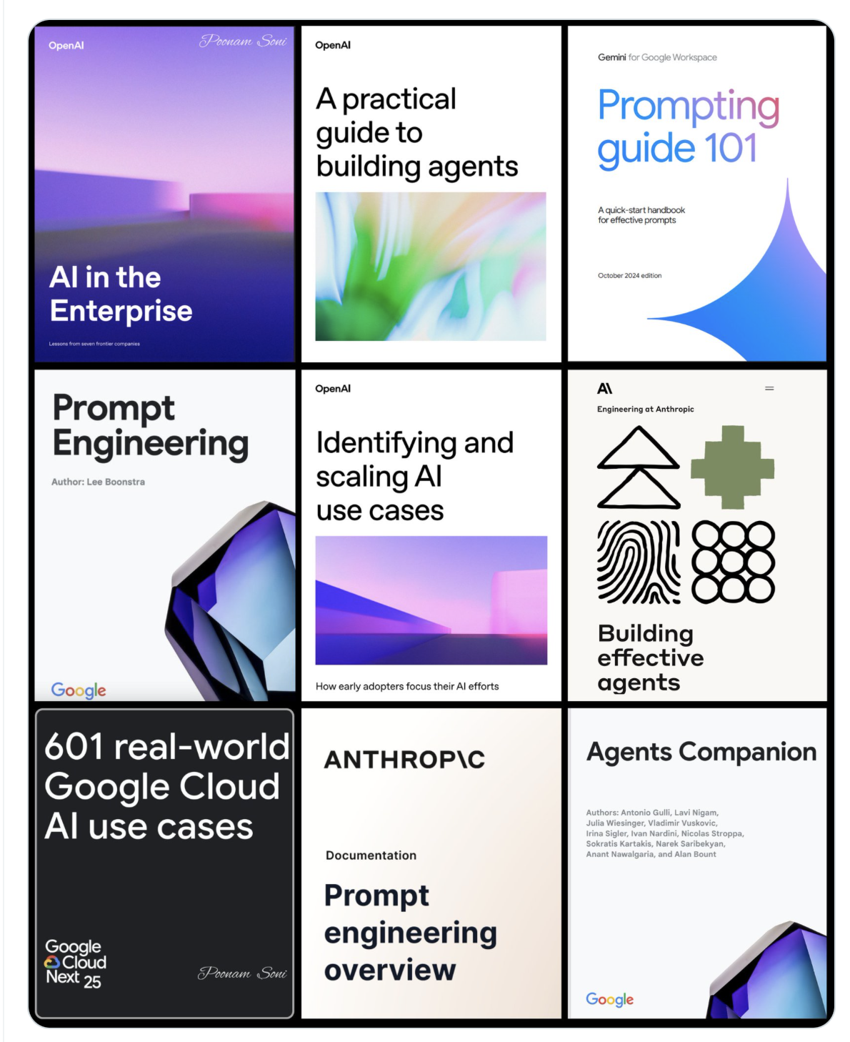

Appendix F- General Business Advice

